Alaska Dressage Association
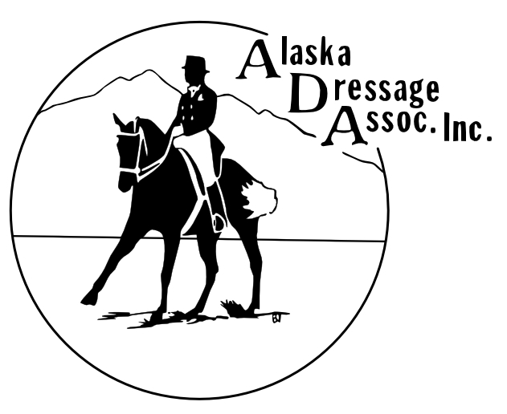
Board Meeting Minutes
February 16, 2021

Call to Order: 5:06pm

Roll Call:
Present: Rosa, Hilary, Brittany, Killian, Leilani, Marcia, Kai

Excused: Char

Approval of Minutes from Last Meeting: did not vote

Treasurer’s Report: balance about the same from last report. Income: ~$400 from silent auction, $500 donation from Sue Mues. Costs: $100 to cover jumper show date change fee

Open Issues (Old Business):
Training for Microsoft office – set date Potentially 2/18 or 2/22 at 7pm. Will check dates with Chris, Sharon and Lauren. Everyone but Hilary and Rosa need credentials reissued. Should now have access to Outlook membership email chain.
Show committee –Think about who can help with Show committee and get back to Rosa by 2/22, responsibilities listed below:
- Establishes licensing and insurance for shows.
- Reserves facility with the Anchorage Horse Council.
- Establishes contracts with show officials, housing for show officials, EMTs, veterinarians, farriers, concession stand.
- Appoints a Hospitality Chairperson to cover care for judges, technical delegates, clinicians, or other guests of ADA functions.
- Coordinates with the Show Manager and Show Secretary of each show.
- Compiles Event Overview Document for each show.

New Business:
Non-show events – schooling shows - split each day into Licensed morning with Schooling/Clinic afternoon (all schooling/clinics must occur after ALL Show tests are completed) or add additional days for schooling shows (Friday before hand, different weekends, valley schooling shows)
ride a test – responsibility of Engagement committee
June Show
Judge –changed to Axel Steiner, update on Facebook and website. His photography wife coming?
Lodging – Marcia stayed at Aspen Suites and cost was good, kitchenette. Nancy Burrows has AirBNB right near center. Using Jane Tibbits for lodging currently.
Coordination with Quarter Horses- Parking biggest issue, work with Zoe
Technical delegate Peter Rothschild- is USDF Director Region 6, have picnic dinner to meet with him

GMO Rep Program – anyone interested or know someone interested in this opportunity?

Article for Region 6 “Winter Riding in Alaska”- provide to Rosa if you have anything you’d like to add or talk about.

Adjourn: 5:57pm

